Confirmation Homework 10/26
The Early Witnesses of the Church

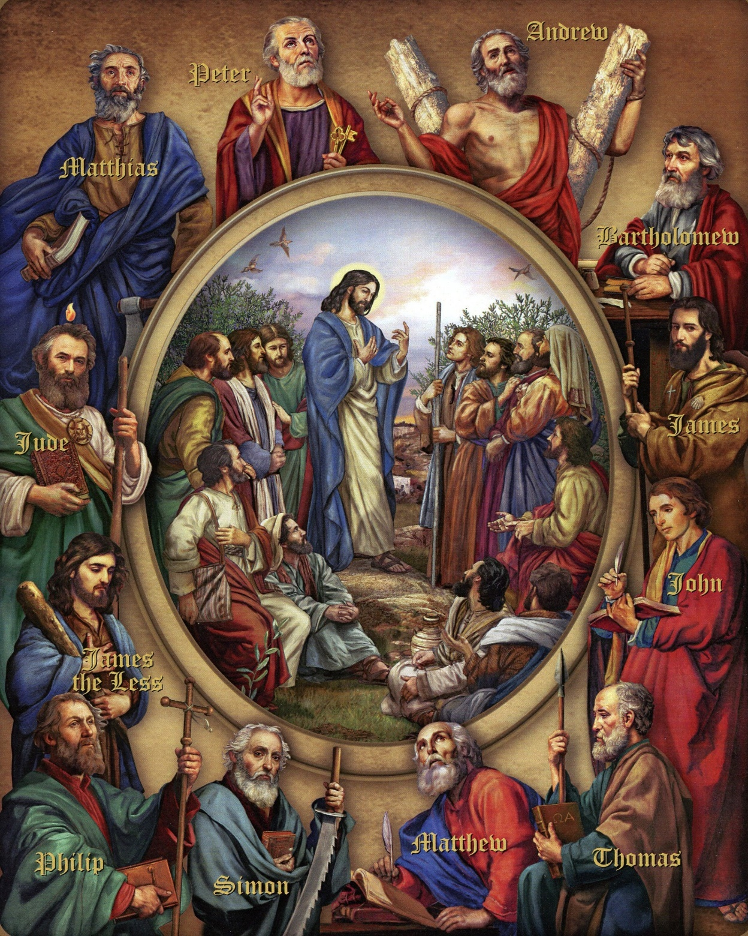

Name___________________________
Jesus chose twelve apostles, and He gave them special authority to lead the Church and to spread His teachings after Jesus went up to Heaven.
There was one problem, however. One of the apostles, Judas Iscariot, had betrayed Jesus. The remaining eleven apostles decided to choose someone who would replace Judas and carry on his teaching authority given by Jesus. In Acts 1, we read about how they chose who should replace Judas.
What do you think is the most important quality they were looking for?

Read Acts 1:15-26. What kind of man were they looking for to replace Judas?

Here is a map of where the apostles went to preach the Gospel.
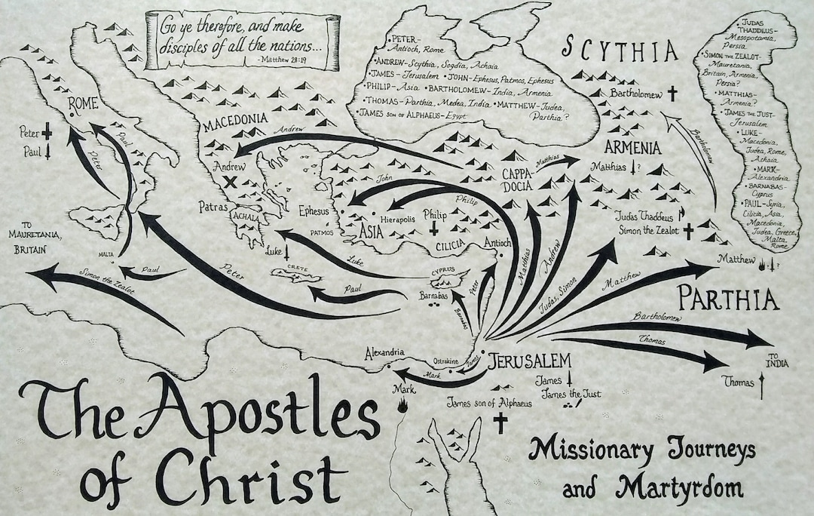

Christianity was completely different from any other way of living that came before it because it taught that God loves each individual person regardless of whether that person is useful or interesting or popular.
This was completely different from the pagan religions that came before, where it was considered acceptable to let people, often even newborn babies, die if they were disabled or considered unwanted. Today, we have an understanding that everyone should be treated with kindness and respect. This idea comes from Christianity.

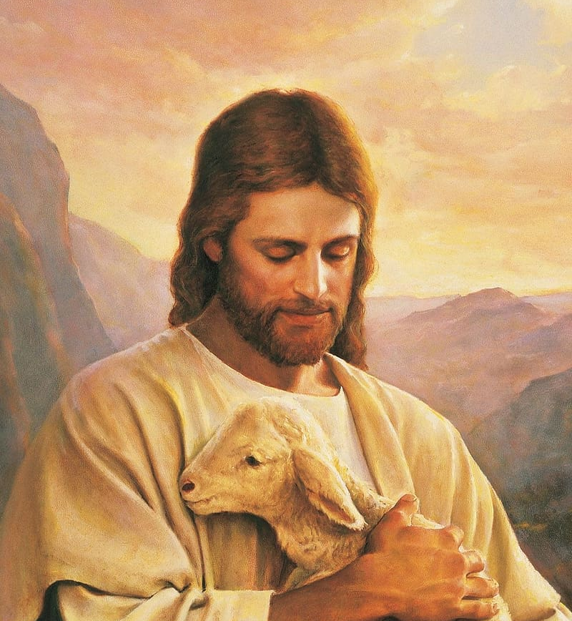

Review and Reflection Questions:
- Each of the twelve apostles that Jesus sent out (except for one) gave their lives freely as martyrs, which means they died giving witness to their faith. What does this tell us about the truth of Jesus’s teaching that these men were willing to die to spread the message?

- Discuss the difference between Christianity and other ancient cultures. How does that mirror modern issues we as Christians face today?

- Reflect on the fact that Jesus died for every single human being that has lived or ever will live. How can you stand up for the dignity of each individual person in your daily life?

